

**PROPERTY PROFESSIONALS**

Submitted by: Muhammad Hamza Farooq

Registration # 200901019

BS-CS01 (B)

Submitted To: Mam Madiha

**Table of Content:**

SIGNIN/SIGNUP 2

HOME 3

CONTACTS 4

ABOUT 5

**Breakdown of Project:**

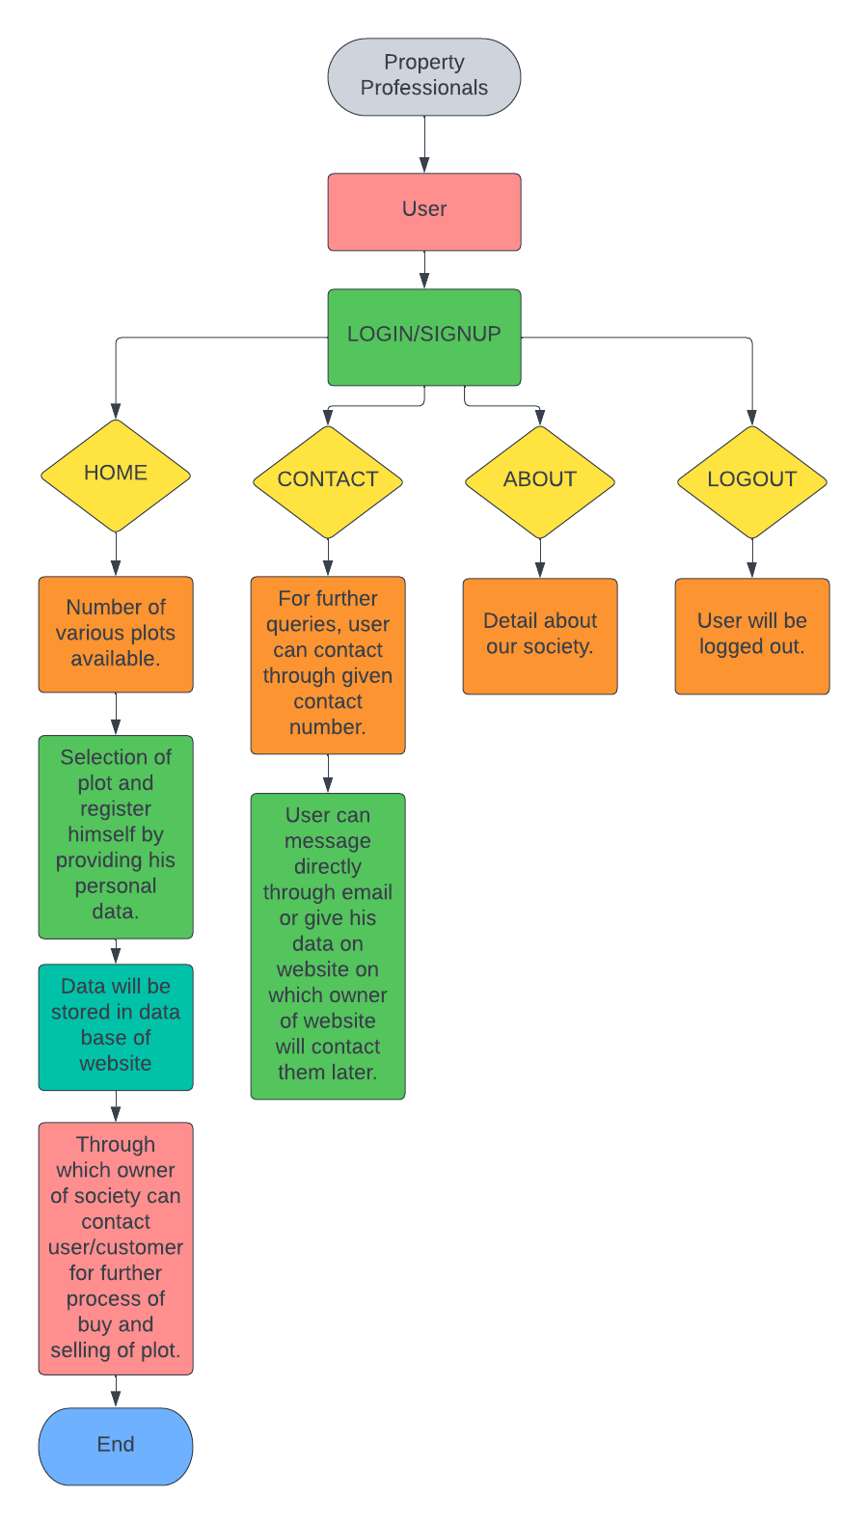

**Sign in:**

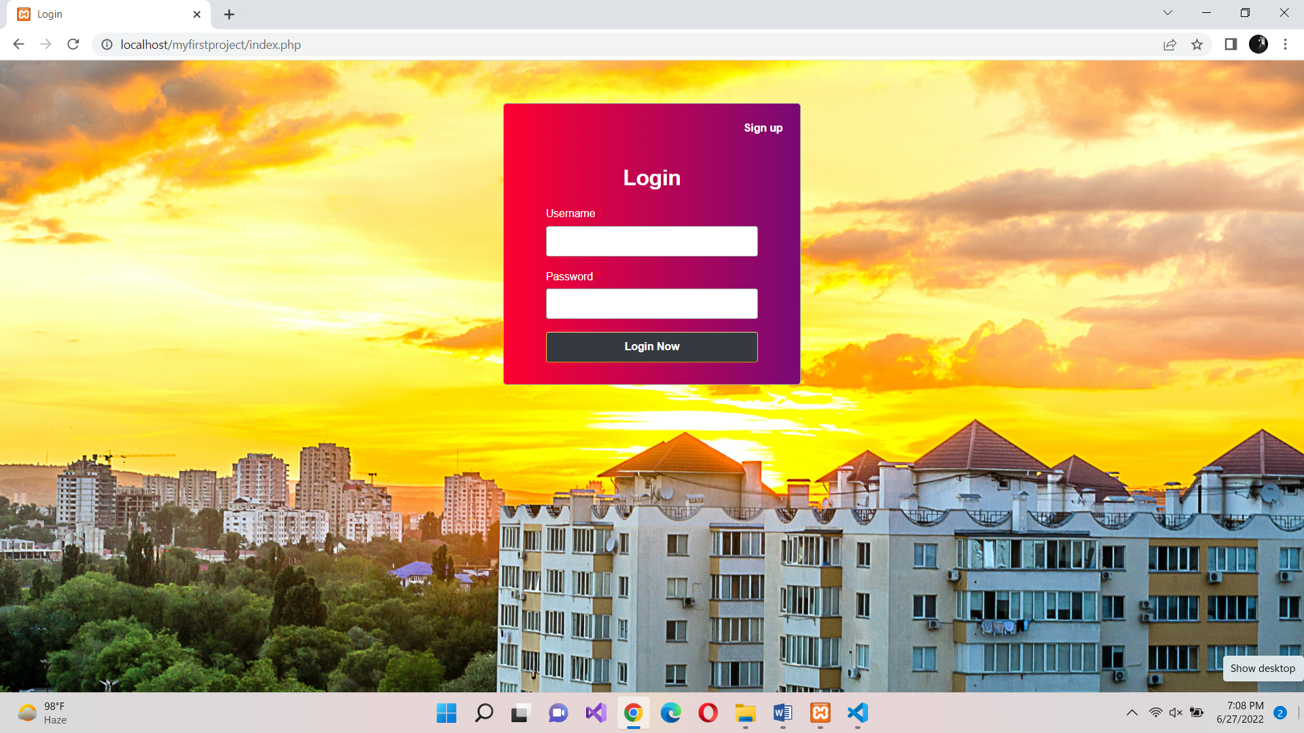

**Sign up:**

If not sign in, then signup to register.

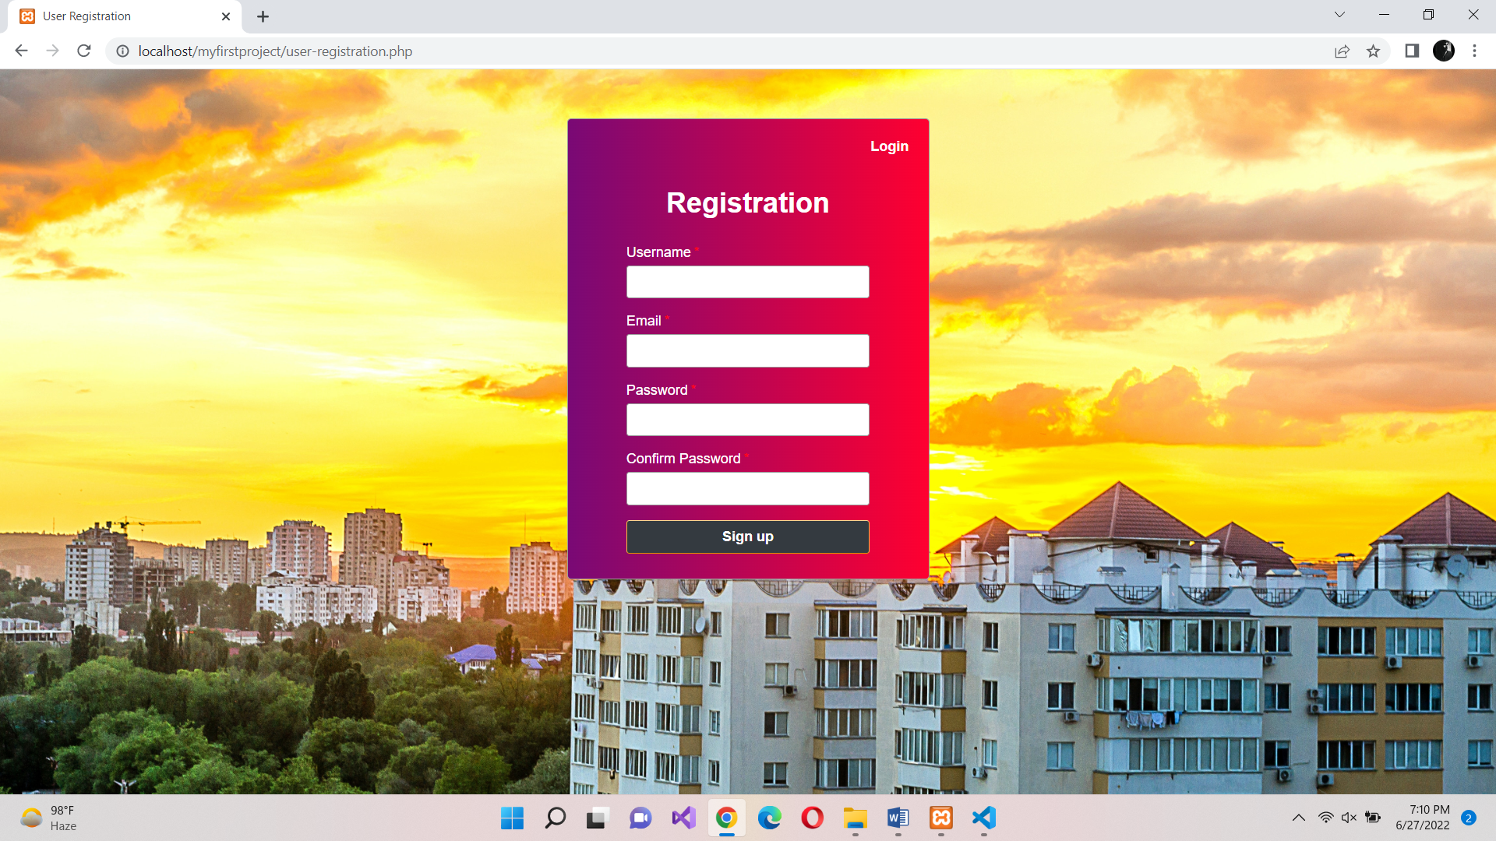

**HOME:**

Number of different types of plots are available in limited amount. Any user can register to buy plots by simply clicking the button below the plot description and provide his data after that.

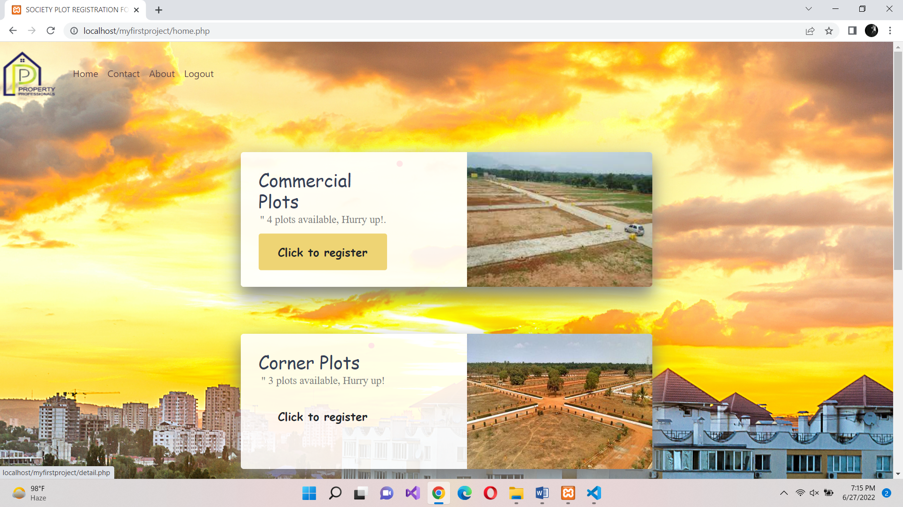

**CONTACT:**

If user want to contact the plot society owner, he can provide his data in the given form on which his data will be transferred to owner and owner will contact him later for his queries.

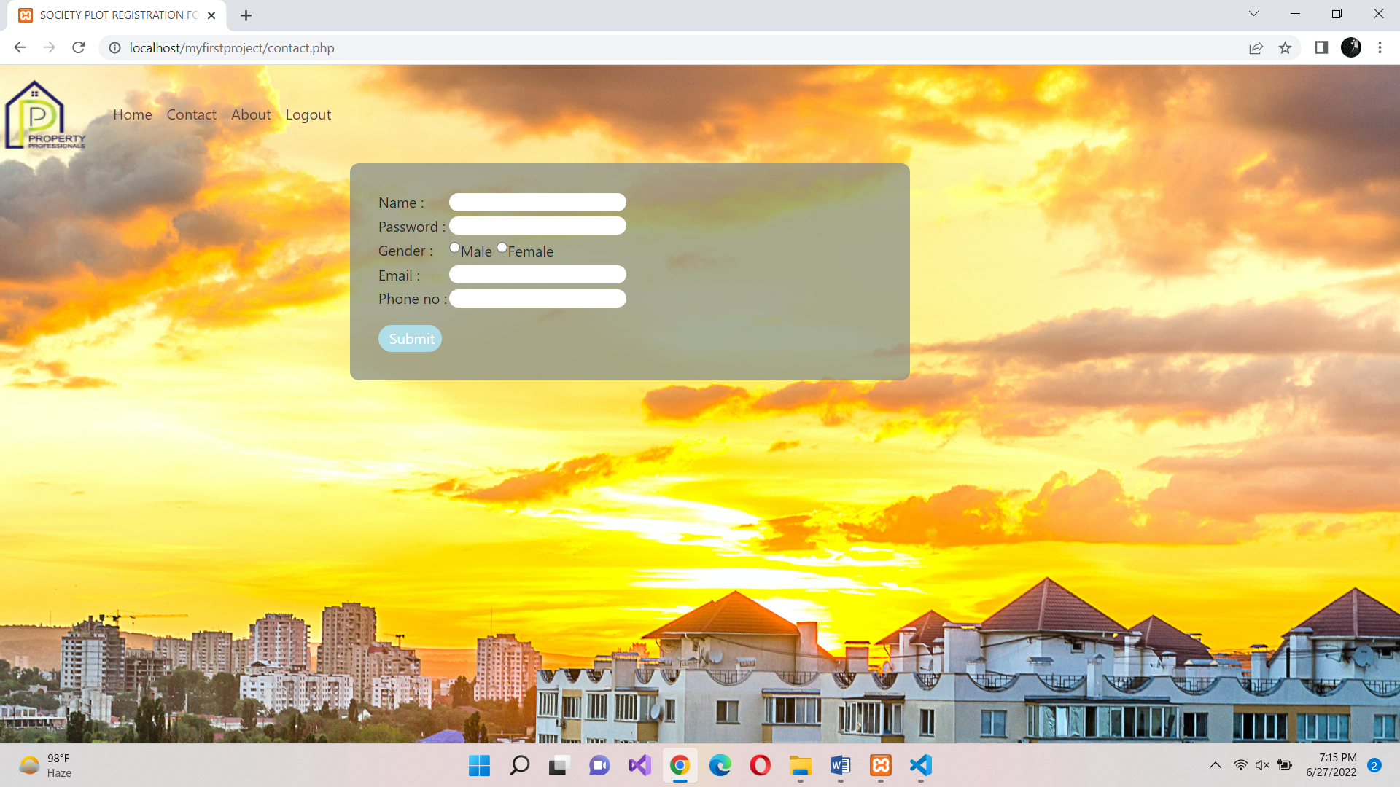

**ABOUT:**

In about section, user will be aware of the website and society as this section contain complete detail of the society. In this section, owner contact number and email is also provided.

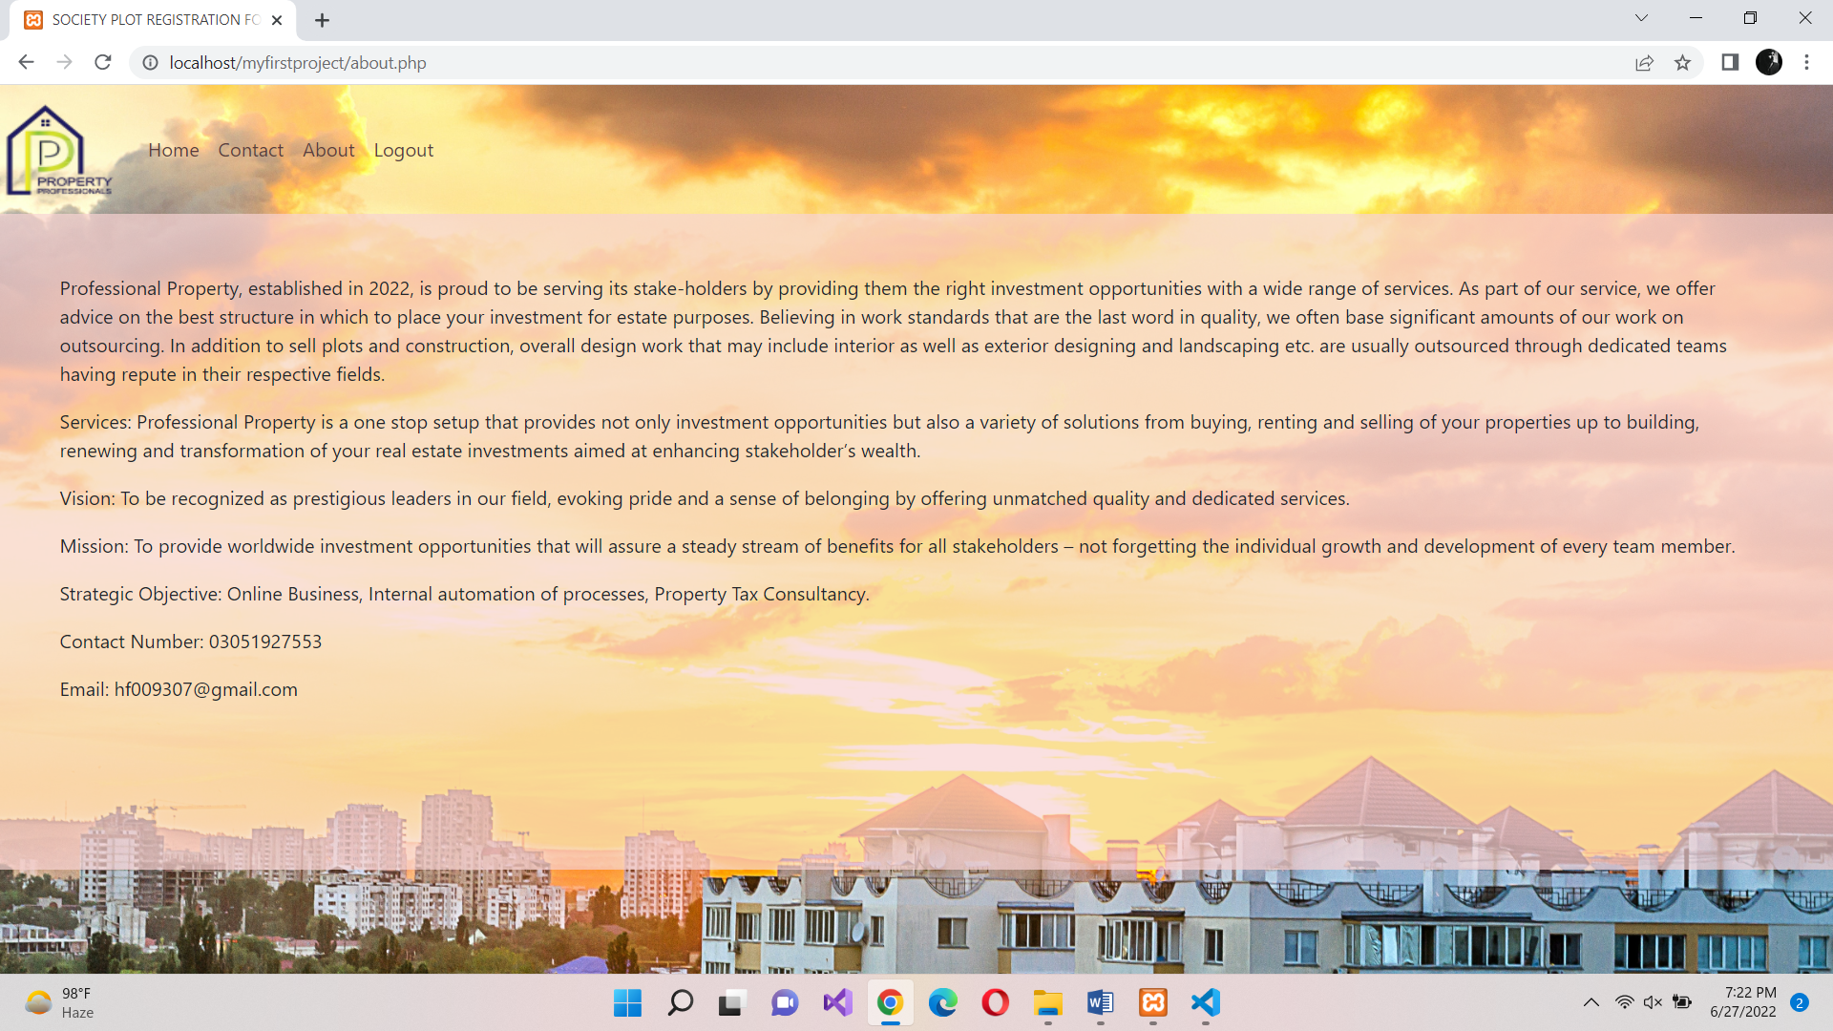

**Note:**

I am using XAMPP as local host for the website.